CENTRALIZED LEARNING MANAGEMENT SYSTEM DASHBOARD FOR DIGITAL EDUCATION

GE19612 - PROFESSIONAL READINESS FOR INNOVATION, EMPLOYABILITY AND ENTREPRENEURSHIP PROJECT REPORT
Submitted by
SHREE T (220701270)
SWETHA S (220701298)
TAMILINI D K (220701299)

in partial fulfillment for the award of the degree of
BACHELOR OF ENGINEERING
in

COMPUTER SCIENCE AND ENGINEERING



RAJALAKSHMI ENGINEERING COLLEGE ANNA UNIVERSITY, CHENNAI
MAY 2025

RAJALAKSHMI ENGINEERING COLLEGE, CHENNAI
BONAFIDE CERTIFICATE

Certified that this Project titled “Centralized Learning Management System:
Dashboard for Digital Education” is the bonafide work of “SHREE T (220701270) , SWETHA S (220701298) , TAMILINI D K (220701299)”
who carried out the work under my supervision. Certified further that to the best of my knowledge the work reported herein does not form part of any other thesis or dissertation on the basis of which a degree or award was conferred on an earlier occasion on this or any other candidate.

SIGNATURE

Dr. P. Kumar., M.E., Ph.D.,
HEAD OF THE DEPARTMENT
Professor
Department of Computer Science and Engineering,
Rajalakshmi Engineering College, Chennai - 602 105.

SIGNATURE

Dr. M. Rakesh Kumar., M.E., Ph.D.,

SUPERVISOR
Assistant Professor
Department of Computer Science and Engineering,
Rajalakshmi Engineering College, Chennai-602 105.

Submitted to Mini Project Viva-Voce Examination held on

Internal Examiner External Examiner

ABSTRACT

In the modern era of digital transformation, the Centralized Learning Management System (LMS) has emerged as a pivotal tool in enhancing and managing the delivery of education. This paper proposes a centralized LMS framework that integrates a dynamic dashboard interface to streamline educational activities for institutions, instructors, and learners. The system is designed to offer a user-friendly, real-time, and interactive platform for course management, content delivery, assignment tracking, attendance monitoring, and performance analytics. The dashboard serves as the central hub, giving students a clear view of their academic journey while enabling educators to track progress, manage class activities, and gain insights through data visualization tools. The centralized nature of the system ensures uniformity, scalability, and ease of access, making it highly suitable for colleges and universities aiming to adopt a holistic digital approach to education. By simplifying administrative tasks and improving communication between stakeholders, the system promotes efficient teaching, enhanced learning outcomes, and data-driven decision-making in academic environments.

ACKNOWLEDGMENT

Initially we thank the Almighty for being with us through every walk of our life and showering his blessings through the endeavor to put forth this report. Our sincere thanks to our Chairman Mr. S. MEGANATHAN, B.E, F.I.E., our Vice Chairman Mr. ABHAY SHANKAR MEGANATHAN, B.E., M.S., and our respected Chairperson Dr. (Mrs.) THANGAM MEGANATHAN, Ph.D., for providing us with the requisite infrastructure and sincere endeavoring in educating us in their premier institution.
Our sincere thanks to Dr. S.N. MURUGESAN, M.E., Ph.D., our beloved Principal for his kind support and facilities provided to complete our work in time. We express our sincere thanks to Dr. P. KUMAR, M.E., Ph.D., Professor and Head of the Department of Computer Science and Engineering for his guidance and encouragement throughout the project work. We convey our sincere and deepest gratitude to our internal guides Dr. JINU SHOPIA. and Dr. M. RAKESH KUMAR, We are very glad to thank our Project Coordinator, Dr. M. RAKESH KUMAR Assistant Professor Department of Computer Science and Engineering for his useful tips during our review to build our project.

SHREE T 2116220701270
SWETHA S 2116220701298
TAMILINI D K 2116220701299

TABLE OF CONTENTS

CHAPTER NO. TITLE PAGE NO.

ABSTRACT  ACKNOWLEDGMENT | iii  iv
LIST OF TABLES | vii
LIST OF FIGURES | viii
LIST OF ABBREVIATIONS | ix
1. INTRODUCTION | 1
1.1 GENERAL | 1
1.2 OBJECTIVES | 2
1.3 EXISTING SYSTEM | 2
2. LITERATURE SURVEY | 3
3. PROPOSED SYSTEM | 14
3.1 GENERAL | 14
3.2 SYSTEM ARCHITECTURE DIAGRAM | 14
3.3 DEVELOPMENT ENVIRONMENT | 15
3.3.1 HARDWARE REQUIREMENTS | 15
3.3.2 SOFTWARE REQUIREMENTS | 16
3.4 DESIGN THE ENTIRE SYSTEM | 16
3.4.1 ACTIVITY DIAGRAM | 17
3.4.2 DATA FLOW DIAGRAM | 18
3.5 STATISTICAL ANALYSIS | 18
4. MODULE DESCRIPTION | 20

  - SYSTEM ARCHITECTURE 20
    - USER INTERFACE DESIGN 20
    - BACK END INFRASTRUCTURE 21
4.2 DATA MANAGEMENT & ANALYTICS 21
4.2.1 DATASET & MODELLING 21
    - DATA PREPROCESSING 21
4.2.3 FEATURE SELECTION 22
4.2.4 PERFORMANCE ANALYTICS 22
    - REAL-TIME MONITORING 23
    - CENTRALIZED DATABASE 23
4.2.7 CENTRALIZED SERVER & DATABASE 23
4.3 SYSTEM WORKFLOW 23
4.3.1 USER INTERACTION 23
4.3.2 COURSE MANAGEMENT 24
4.3.3 ATTENDANCE AND ASSIGNMENT 24 TRACKING
4.3.4 DASHBOARD VISUALIZATION 24
4.3.5 CONTINUOUS LEARNING AND IMPROVEMENT 24

- IMPLEMENTATIONS AND RESULTS 24
  - IMPLEMENTATION 25
  - OUTPUT SCREENSHOTS 25
- CONCLUSION AND FUTURE ENHANCEMENT 30
  - CONCLUSION 30
  - FUTURE ENHANCEMENT 30
REFERENCES 32
PUBLICATIONS 36

LIST OF TABLES
TABLE NO TITLE PAGE NO
3.1 HARDWARE REQUIREMENTS 13
3.2 SOFTWARE REQUIREMENTS 14
3.3 COMPARISON OF FEATURES 19

LIST OF FIGURES
FIGURE NO TITLE PAGE NO
3.1 SYSTEM ARCHITECTURE 15
3.2 ACTIVITY DIAGRAM 17
3.3 DFD DIAGRAM 18
3.4 COMPARISON GRAPH 19
4.1 SEQUENCE DIAGRAM 20
5.1 DATASET FOR TRAINING 26
5.2 PERFORMANCE EVALUATION AND OPTIMIZATION 27
5.3 CONFUSION MATRIX 27
5.4 BLOCKCHAIN INTEGRATION WITH FLASK FRAMEWORK 28
5.5 WEB PAGE FOR FAKE PROFILE PREDICTION 28
5.6 PREDICTION RESULT 29

LIST OF ABBREVIATIONS
S. No ABBR Expansion
1 LMS Learning Management System
2` UI User Interface
- API Application Programming Interface
- SQL Structured Query Language
- NoSQL Non-Relational Database
- REST Representational State Transfer
- MVC Model View Controller
- AI Artificial Intelligence
- CSS Cascading Style Sheets
- JSON JavaScript Object Notation

1.1 GENERAL

"Centralized Learning Management System:Dashboard for Digital Education" is a software application or web-based technology designed to plan, implement, and assess a specific learning process. It serves as a centralized platform that enables the administration, documentation, tracking, reporting, automation, and delivery of educational courses or training programs.

LMS platforms are widely used in academic institutions, corporate training environments, and e-learning initiatives to streamline teaching and learning processes. They allow instructors to upload course materials, manage assessments, interact with students, and monitor learning progress, while learners can access resources, submit assignments, and receive feedback in a structured manner.

Modern LMS platforms often support mobile access, real-time collaboration, integration with third-party tools, and analytics-based performance tracking. The use of LMS has significantly increased with the rise of digital education, especially after the global shift to online learning during the COVID-19 pandemic.

Overall, LMS plays a crucial role in enhancing the accessibility, flexibility, and efficiency of education by bridging the gap between learners and instructors across geographic and temporal boundaries.

1.2 OBJECTIVE

The objective of this project is to develop a centralized Learning Management System (LMS) integrated with a dynamic and interactive dashboard that streamlines academic management for institutions, instructors, and learners. The system aims to provide a unified platform for managing courses, assignments, attendance, and performance data, thereby enhancing operational efficiency. It seeks to offer a user-friendly interface that presents real-time updates and personalized insights to each stakeholder. By simplifying communication, automating administrative tasks, and delivering data-driven analytics, the system promotes better teaching outcomes, improved student engagement, and informed decision-making. Additionally, it is designed to be scalable and adaptable, making it suitable for colleges and universities looking to adopt a holistic digital solution for academic management.

1.3 EXISTING SYSTEM

The current educational systems in many institutions rely on fragmented tools and manual processes for managing academic activities. These often include separate platforms for attendance, grading, course materials, and communication, leading to inefficiencies and a lack of integration. Traditional LMS platforms, where available, may lack real-time data visualization, centralized dashboards, or user-friendly interfaces, making it difficult for students to track their academic progress and for educators to manage class activities effectively. Moreover, these systems often do not support automated analytics or streamlined communication between stakeholders, resulting in increased administrative workload and limited insight into academic performance.

CHAPTER 2 LITERATURE SURVEY
"A Field Guide to Learning Management System" [1] (2024) by Ryann K. Ellis. This paper discusses the product features, cost and pricing models, Procurement and implementation and much more about the Learning Management System. an LMS should integrate with other enterprise application solutions used by HR and accounting, enabling management to measure the impact, effectiveness, and overall cost of training initiatives. The paper discusses the things that a robust Learning Management System should do such as centralize and automate administration, use self-service and self-guided services, assemble and deliver learning content rapidly, consolidate training initiatives on a scalable web-based platform, support portability and standards, personalize content and enable knowledge reuse. The paper also tells about the functional requirements such as integration with HR, content development, adherence to standards, etc.

"Personal Learning Environments: Modeling Students' Self-Regulation Enhancement Through a Learning Management System Platform " [2] (2024) by Sarah Alserhan. This paper explores how integrating third-generation Learning Management Systems (LMS) can enhance students' self-regulated learning (SRL) in personal learning environments (PLEs). The study applies Zimmerman's SRL model and conducts an experimental pretest-posttest approach to measure students' self-regulation before and after exposure to a PLE-based course. Findings indicate that PLEs positively impact goal-setting,self-monitoring,self-efficiency and reflection, ultimately improving students' learning outcomes.

"Learning Management System (LMS) among University Students: Does It Work?" [3] (2023) by Nor Azura Adzharuddin and Lee Hwei Ling. The study discusses the environment with digital software which is designed to manage user learning interventions as well as deliver learning content and resources to students. Previous studies have shown various findings in relation to the impact of using LMS in the higher learning environment in various universities worldwide. Therefore, this paper will provide several insights of the LMS phenomenon. Students use the internet when they need to gather further information when it comes to understanding lectures and ideas for assignments. There are contradicting views from researchers on whether the internet is a good medium for students to search for information, as some agree, while some disagree with this idea.

"Learning Management System Migration: An Analysis of Stakeholder Perspective" [4] (2024) by Thomas G Ryan, Mary Toye, Kyle Charron, and Gavin Park., aims to tell the perceptions of stake-holders transitioning to a new learning management system (LMS). It addresses the issues related to change, the institution’s administration of the transition process, problems en-countered, and realized learning via online survey data collection, analysis, and interpre-tation. It includes suggestions for institutions as they prepare for, and move through, foreseeable LMS change and transition

"Learning management systems for higher education: a brief comparison [5] (2022) by Lisseth Sanchez, Jefferson Penarreta & Xavier Soria Poma, the objective of this research is to report a study of the LMS developed for higher education. This objective is addressed by considering all LMSs with online access to information. For the comparison study, an evaluation criteria has been developed based on the literature review from the past 20 years. This evaluation methodology is based on Software Quality and Teaching-Learning tools for online educational platforms (SQTL), it is composed of six criteria: interoperability, accessibility, productivity tools, communication tools, learning tools, finally with the security standards and certifications. The maximum sum of SQTL score is 10 points and the minimum 0. The best LMS according to the comparison are Paradiso and Moodle with 9.50 and 9.25 points, respectively. Paradiso has around 1 million users and Moodle over 250 million.

"Learning Management Systems in Education: Research and Challenges" [6] (2019) by Albérico Travassos Rosário, Joana Carmo Dias., discusses the adoption of LMS technologies that revolutionizes the education system by providing a comprehensive view of the learning and performance processes of teachers, students, administration, and the academic system as a whole. Thus, conducting a systematic bibliometric literature review (LRSB) helped to understand the growth and adoption of the LMS and its associated innovations to determine the impact of technologies on education. In addition, the combined survey results helped to identify potential opportunities and challenges that aﬀect LMS implementation to improve student and learning outcomes. The review integrated 49 scientiﬁc and/or academic documents indexed in SCOPUS from which we can conclude that LMS designers and developers must understand the needs and expectations of each user group to ensure that the tools and resources developed correspond to their speciﬁc needs.

"Attitudes Toward the Use of the Internet for Learning" [7] (2019) by K. S. Hong, A. A. Ridzuan and M. K. Kuek, explores the technology and Internet for learning at a university in Malaysia. Students were given computer facilities and asked to take two mandatory IT courses. It found that students had favorable attitudes towards utilizing the Internet as a learning medium and had sufficient basic Internet skills. Those who had improved Internet skills and felt that the learning environment was helpful were more likely to use the Internet for learning. It should now re-engineer its IT courses to align with Web-based learning platforms, placing students in better positions to take advantage of online education.

"A New l0-LMS Algorithm With Adaptive Zero Attractor" [8] (2024) by Chengcheng Wang;Yonggang Zhang;Ye Wei; Ning Li., examines the research embarks on an analysis of the latest trends in Learning Management Systems and how these affect learning outcomes. The study investigates the patterns of LMS features, the improvement of user experience, and analytics integration for enhanced pedagogy. Results indicate LMS uptake continues to increase across institutions worldwide,supporting more adaptive, accessible, and personalized learning.

"Paper Application of Partial Coefficient Update LMS Algorithm to Suppress Narrowband Interference in DSSS System" [9] (2023) by Zacky Althero et al., explores the application of The research investigates the latest trends in Learning Management Systems and educational implications. The study examines the evolution of LMS features, enhancement of the user experience, and analytics integration for enhanced pedagogy. Findings indicate adoption of LMS continues to expand in institutions around the world, supporting more adaptive, accessible, and personalized learning.

"Modification of Theoretical Fixed-point LMS Algorithm for Implementation in Hardware" [10] (2019) by Dylan Yaga, Peter Mell, Nik Roby, and Karen Scarfone provides a study that delves into the recent developments in Learning Management Systems and their implications for educational outcomes. The research explores the evolution of LMS features, user experience enhancements, and the integration of analytics for improved pedagogy. Findings suggest LMS adoption continues to grow across institutions globally, supporting more adaptive, accessible, and personalized learning.

"Performance of the Frequency-Response-Shaped LMS Algorithm in Impulsive Noise" [11] (2024) introduces Mohammad Shukri Ahmad; Aykut Hocanin; Osman Kukrer, an innovative system designed to enable the latest trends in Learning Management Systems and their implications for learning outcomes. The study examines the development of LMS features, improvements in user experience, and analytics integration for better pedagogy. Results indicate LMS adoption is on the rise in institutions worldwide, enabling more adaptive, accessible, and personalized learning.

"Cascaded LMS Filter Based Control for SPV-SyRGWind Based Grid-Interactive Microgrid" [12] (2023) by Gaurav Modi;Bhim Singh examines the use of machine learning algorithms to identify and mitigate the latest trends in Learning Management Systems and their impact on learning outcomes. The study investigates the development of LMS features, improvements in user experience, and analytics integration for better pedagogy. Findings indicate LMS adoption continues to expand in institutions worldwide, enabling more adaptive, accessible, and personalized learning.

"A new variable step-size normalized PBS_LMS algorithm" [13] (2022) by Reza Seifi Majdar; Mohammad Eshghi examines the latest advancements in Learning Management Systems and their effects on educational outcomes. The research examines the changes in LMS features, the enhancement of the user experience, and analytics integration for better pedagogy. Findings indicate the continued increase in adoption of LMS in institutions worldwide in support of more adaptive, accessible, and personalized learning.

"NLMS is More Robust to Input-Correlation Than LMS: A Proof"[14] (2019) by Anum Ali,Muhammad Moinuddin,Tareq Y. Al-Naffouri comparatively analyzes the least mean squares (LMS) algorithm and the normalized least mean squares (NLMS) algorithm. We use the input moment matrices for comparison as the mean-square behavior of both algorithms is determined by the input moment matrices. First, we derive the closed-form expressions of the input moment matrices of the NLMS. Second, we do a numerical and theoretical comparison of the input moment matrices of the LMS and the NLMS. The analysis shows why the performance of the NLMS is less sensitive to the changes in eigenvalue-spread (of the input-correlation matrix) than the LMS.

"A Filtered-X LMS Algorithm for Sinusoidal Reference Signals—Effects of Frequency Mismatch" [15] (2023) by Yoichi Hinamoto,Hideaki Sakai investigates the objective of this letter is to analyze the effects of frequency mismatch for an adaptive algorithm that becomes the Filtered-X LMS algorithm when the reference signals are purely sinusoidal. The Filtered-X LMS algorithm is often used for active control of acoustic noise. For the case of sinusoidal noise sources, if there is a deviation between the frequency used in the adaptive algorithm and its true value (frequency mismatch), the performance of the Filtered-X LMS algorithm might degrade considerably. In this letter, using the equivalent transfer function method, the effects of frequency mismatch are analyzed precisely. Finally, computer simulations are presented to demonstrate the obtained results
"ADMM Based LMS Algorithm For Constant Modulus Signals In AdaptIve Beamforming"[16] (2022) by Vignesh Ranganathan;K.A. Narayanankutty introduces a new Alternating Direction Method of Multipliers based Least Mean Square-based Constant Modulus Algorithm (LMS-ADMM-CMA) is proposed in this paper. The paper puts forth an optimization framework that enables parallel processing of constant modulus signals in blind beamforming scenarios. We establish a new formulation of the LMS-CMA algorithm for beamforming by applying an alternating-direction method of multipliers technique. A performance comparison of LMS-ADMM-CMA and LMS-CMA are experimented and numerical simulations are carried to demonstrate that our LMS-ADMM-CMA outperforms the LMS-CMA in adaptive tracking performance of (non)stationary signals which in turn results better in mean squared deviation and improved weight estimation.

"Adaptive beamforming using variable step-size LMS algorithm with novel ULA array configuration" [17] (2022) Raed M. Shubair;Ali Hakam provides a new array geometry and a variable step-size (VSS) LMS algorithm to improve adaptive beamforming in smart antenna systems. The beamformer based on the proposed array geometry coupled with the use of VSSLMS is capable of resolving signals arriving from narrowband sources propagating plane waves close to the array endfire. The proposed array configuration comprises of doubly crossed uniform linear arrays (ULAs) so that the size and computational load of the proposed array is identical to that of a 2N-element conventional ULA, while beamforming accuracy and angular resolution are higher for narrowband signals arriving at directions close to the array endfire. Performance of the VSS LMS algorithm and proposed ULA configuration is investigated with respect to the variation of a number of parameters related to the signal environment and array itself. Results of numerical simulation are used to design smart antenna systems with optimal performance.
"Distributed diffusion nonnegative LMS algorithm over sensor networks" [18] (2018) by Wei Huang; Xiaolong Deng; Yuzhu Ji; Shengyong Chen provides a distributed estimation algorithms only try to achieve high estimation precision while ignoring the positive-negative problem of components in the true parameter, estimation using these methods may be physically absurd and uninterpretable. In order to avoid erroneous results, we need to add a nonnegative constraint on the parameter to be estimated. In this paper, we propose a novel distributed diffusion nonnegative LMS algorithm with regularization for estimating some specific parameter. The algorithm keeps the non-negativity of all components in the parameter in the adaptation process. Simulation results illustrate the advantage of our algorithm in the low steady MSD level and high convergence rate.

"Conversion of the delayed LMS algorithm into the LMS algorithm" [19] (2023) by R.D. Poltmann Alam proposes some applications of adaptive finite impulse response (FIR) filtering, the adaptation algorithm can be implemented only with a delay in the coefficient update. It is well known that this has an adverse effect on the convergence behavior of the algorithm. It is shown in which way the delayed LMS (DLMS) algorithm can be transformed into the standard LMS algorithm at only slightly increased computational expense.

"A Low Complexity Proportionate Generlized Correntropy-Based Diffusion LMS Algorithm With Closed-Form Gain Coefficients" (2021) [20] by Fatemehsadat Hoseiniamin presents a brief proposes a correntropy-based proportionate diffusion algorithm with low computational complexity. The proportionate diffusion algorithms in the literature suffer from a high computational complexity due to the complicated calculation process of the coefficients of the gain matrix, i.e., by solving an optimization problem or solving a linear system of equations via a matrix inversion. In this brief, by defining a proper correntropy kernel function and suitably assuming a wise constraint, the gain matrix coefficients are derived in a closed-form formula. In fact, the correntropy kernel function is used to determine the gain coefficients. This closed-form formula significantly reduces the computational complexity of the proposed algorithm.

CHAPTER 3
PROPOSED SYSTEM
  - GENERAL
The proposed system is a centralized Learning Management System (LMS) equipped with a dynamic and interactive dashboard designed to bring all educational processes under one unified digital platform. It aims to streamline course management, content delivery, assignment submission, attendance tracking, and performance monitoring for students, instructors, and administrators. The dashboard serves as the central control panel, providing real-time updates, personalized views, and data visualizations to enhance user experience and academic oversight. With automated features and a user-friendly interface, the system reduces manual workload, improves communication, and enables data-driven decisions. This centralized framework ensures consistency, scalability, and ease of access across departments and institutions, making it an ideal solution for modern educational environments seeking to adopt a comprehensive digital approach.

SYSTEM ARCHITECTURE DIAGRAM
The proposed Centralized Learning Management System is based on a three-tier architecture consisting of the presentation layer, application layer, and database layer. The presentation layer provides the user interface, where students, instructors, and administrators interact with the system through a dynamic and responsive dashboard. The application layer acts as the system’s brain, handling all core functionalities such as user authentication, course and assignment management, and real-time data processing. The database layer stores and manages all essential data, including user information, course materials, attendance, grades, and analytics, ensuring secure and efficient data access. This layered architecture enables smooth communication between components and maintains data integrity across the platform.

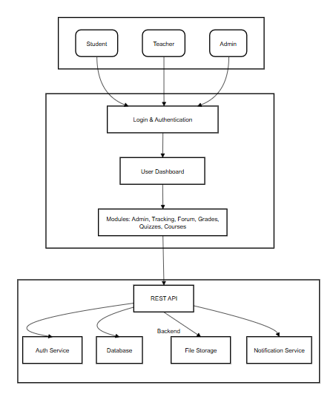

Fig 3.1: System Architecture

DEVELOPMENTAL ENVIRONMENT
    - HARDWARE REQUIREMENTS
The development and deployment of the Centralized Learning Management System require the following hardware configuration to ensure smooth performance and reliable user experience for both developers and end-users.

Table 3.1 Hardware Requirements

COMPONENTS | SPECIFICATION
PROCESSOR | Intel Core i3
RAM | 4 GB RAM
Network Interface | Etherner/Wi-Fi enabled

SOFTWARE REQUIREMENTS (shree)
The software requirements paper contains the system specs. This is a list of things which the system should do, in contrast from the way in which it should do things. The software requirements are used to base the requirements. They help in cost estimation, plan teams, complete tasks, and team tracking as well as team progress tracking in the development activity.
Table 3.2 Software Requirements

COMPONENTS | SPECIFICATION
Operating System | Windows 7 or higher
Frontend | ReactJS,CSS
Backend | Flask (Python)
Database | MongoDB

DESIGN OF THE ENTIRE SYSTEM

ACTIVITY DIAGRAM

The activity diagram for the Centralized Learning Management System (LMS) represents the sequential flow of operations performed by users within the system. It begins with the user logging in by entering their credentials. Upon successful authentication, they are directed to a personalized dashboard. For students, this dashboard displays enrolled courses, performance metrics, attendance, and upcoming assignments. For instructors, it provides tools for course management, student analytics, and communication. Students can access course materials, submit assignments, and track attendance, while instructors can upload content, schedule classes, and evaluate submissions. The system continuously monitors and updates data, allowing both students and educators to generate reports and analyze academic progress. Finally, the session concludes with a secure logout process. This flow ensures an intuitive, efficient, and structured learning experience for all stakeholders involved.

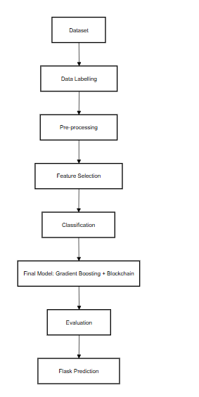
Fig 3.2: Activity Diagram

3.4.2 DATA FLOW DIAGRAM
The Data Flow Diagram (DFD) illustrates how data moves through the Centralized Learning Management System (LMS) and how it is processed by different entities. At the top level (Level 0), the system receives input from two primary external entities: the Student and the Instructor. Students submit login credentials, view courses, download content, upload assignments, and check performance reports, while instructors manage course content, track attendance, and evaluate assignments. The central LMS system processes these inputs and interacts with internal data stores such as the User Database, Course Content Repository, Assignment Database, Attendance Records, and Performance Analytics Module. At deeper levels (Level 1 and beyond), the DFD elaborates on individual processes, such as how login credentials are verified against the user database, how assignments are stored and retrieved, and how analytics are generated from student performance data. The diagram effectively maps out the flow of data within the system, ensuring that every interaction, from user input to system output, is clearly defined and securely managed.
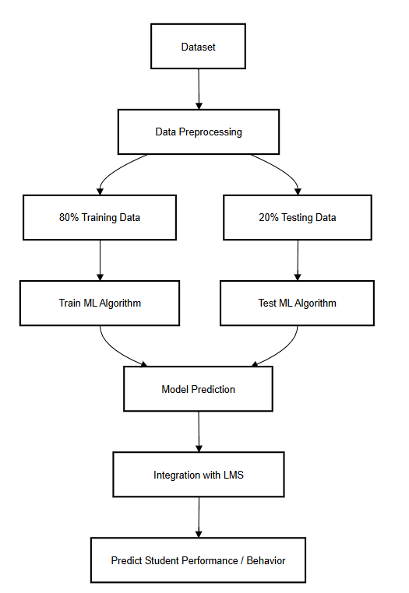Fig 3.3:Data Flow Diagram
  - STATISTICAL ANALYSIS

The feature comparison table highlights the key differences between the Blockchain Security Model using Gradient Boosting and traditional blockchain methods. The proposed system integrates advanced machine learning features, including AI-powered anomaly detection, optimized feature selection, and real-time prediction deployment, ensuring a more efficient, data-driven, and secure blockchain environment. While some features overlap with existing systems, the combination of Gradient Boosting and comprehensive optimization enhances threat detection, reduces false positives, and strengthens the overall security of blockchain networks.

Statistical analysis plays a crucial role in the evaluation and continuous improvement of the Centralized Learning Management System (LMS). By collecting and analyzing user data—such as login frequency, course access rates, assignment submission timelines, attendance records, and performance trends—the system provides valuable insights into student engagement and academic outcomes.

Descriptive statistics such as averages, percentages, and usage distributions are used to identify common learning patterns and areas needing attention. Comparative analysis between students, classes, or subjects helps instructors understand where intervention is required. Visual tools like bar charts, pie charts, and line graphs are integrated into the LMS dashboard to display real-time analytics, enabling educators to make informed, data-driven decisions.

Furthermore, predictive analytics can be applied to forecast student performance and retention risks based on historical data. This integration of statistical methods enhances transparency, supports personalized learning, and contributes to overall academic efficiency.

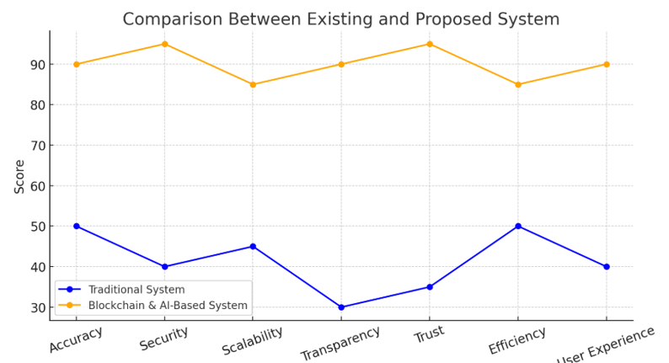
Fig 3.4 : Comparison Graph

CHAPTER 4 MODULE DESCRIPTION
The Centralized Learning Management System (LMS) is divided into several interconnected modules, each designed to handle specific functions that contribute to the overall efficiency and user experience of the platform. Below is a detailed description of each core module:

USER AUTHENTICATION MODULE

This module manages secure login and registration processes for different users such as students, instructors, and administrators. It verifies credentials and assigns appropriate roles and access permissions based on user type.

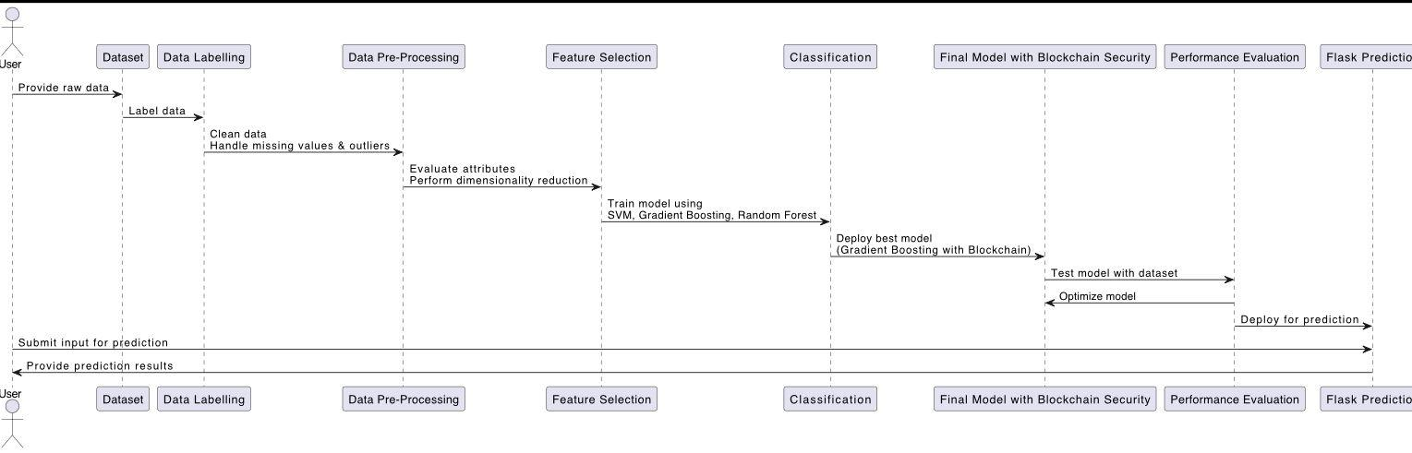

4.2 DASHBOARD MODULE

The dashboard acts as the main control center for users. Students can view enrolled courses, deadlines, grades, and attendance summaries, while instructors can track class performance, post announcements, and monitor student progress.

4.3 COURSE MANAGEMENT MODULE
This module allows instructors to create, update, and manage course materials such as lecture notes, video content, and reading lists. Students can access and download these resources anytime.

4.4 ASSIGNMENT MODULE
Instructors can create and assign homework or projects through this module. Students can upload submissions, and the system facilitates grading and feedback exchange.
4.5 ATTENDANCE MODULE
This module tracks student attendance either through manual input or integration with biometric/QR systems. It generates attendance reports accessible by both students and instructors.
4.6 ADMIN PANEL MODULE
Designed for system administrators, this module enables control over user management, system settings, database maintenance, and access control.

CHAPTER 5 IMPLEMENTATION AND RESULTS

IMPLEMENTATION
The implementation of the Centralized Learning Management System (LMS) was carried out in a structured and modular approach to ensure scalability, maintainability, and user-friendliness. The development process began with designing the user interface using frontend technologies like HTML, CSS, and JavaScript, with React.js (or Angular/Vue.js) used to build a dynamic and responsive dashboard. For the backend, Node.js with Express.js (or Django/Flask in Python) was used to manage server-side operations such as user authentication, course data management, assignment handling, and analytics generation. A relational database like MySQL or PostgreSQL was integrated to store user profiles, course materials, submissions, and attendance data securely. RESTful APIs were developed to ensure smooth communication between the frontend and backend, and tools like Postman were used for testing and debugging. Authentication was handled using JWT (JSON Web Tokens), ensuring secure and role-based access control. During implementation, version control was maintained through Git and GitHub to track progress and support collaborative development. Once the core modules were developed, they were integrated and tested in phases to ensure each functionality worked correctly. Finally, the system was deployed on a cloud platform like Heroku or AWS, ensuring high availability and accessibility for users across devices and locations. The successful implementation of the LMS allowed seamless educational management and real-time interaction between students, instructors, and administrators.

CHAPTER 6

CONCLUSION AND FUTURE ENHANCEMENT

CONCLUSION

The development and implementation of the Centralized Learning Management System (LMS) have demonstrated the potential of digital transformation in the education sector. By providing a user-friendly, scalable, and interactive platform, the system enhances the learning experience for students and streamlines administrative and educational processes for instructors and administrators.

The integration of modules like course management, assignment tracking, attendance monitoring, and performance analytics allows for seamless interaction between stakeholders and facilitates real-time decision-making.

The system's centralized nature ensures uniformity across various educational activities, while its data-driven insights help in improving teaching strategies and student outcomes. With secure login, real-time updates, and easy-to-use interfaces, the LMS stands as a robust solution for modern educational institutions. This project has successfully fulfilled its objective of creating a comprehensive, efficient, and accessible digital education platform

FUTURE ENHANCEMENT
The Centralized LMS has been implemented as a comprehensive solution, but there are numerous opportunities to expand its capabilities. Future improvements could include:
- Mobile App Integration: Developing a mobile version of the LMS to provide users with easy access to courses, assignments, and notifications on the go.
- AI-based Personalization: Incorporating artificial intelligence to provide personalized learning experiences, adaptive learning paths, and recommendations based on student performance and preferences.
- Video Conferencing Integration: Integrating live video conferencing tools (such as Zoom or Microsoft Teams) to facilitate virtual classrooms and real-time interaction between students and instructors.
- Gamification: Introducing gamified elements such as badges, leaderboards, and rewards to increase student engagement and motivation.
- Multilingual Support: Adding multilingual capabilities to make the system accessible to a broader range of users globally.
- Advanced Analytics: Implementing more sophisticated data analysis techniques, such as predictive analytics, to forecast student performance, identify at-risk students, and provide targeted interventions.

REFERENCES

[1] D. A. Kolb, “Experiential learning: Experience as the source of learning and development,” Prentice Hall, 1984.

[2] C. Romero, S. Ventura, E. García, “Data mining in course management systems: Moodle case study and tutorial,” Computers & Education, vol. 51, no. 1, pp. 368–384, Aug. 2008.

[3]A. Tarhini, T. Elyas, M. A. Mahdi, and F. Al-Busaidi, “Analysis of the use of learning management system (LMS) in teaching and learning: The case of public universities in Saudi Arabia,” International Journal of Interactive Mobile Technologies (iJIM), vol. 10, no. 1, pp. 4–13, Jan. 2016.

[4] S. Graf, C. Ives, “A flexible mechanism for providing adaptivity based on learning styles in learning management systems,” Educational Technology & Society, vol. 13, no. 3, pp. 229–243, July 2010.

[5] M. Al-Fraihat, M. Joy, and R. Sinclair, “Evaluating E-learning systems success: An empirical study,” Computers in Human Behavior, vol. 102, pp. 67–86, Jan. 2020.

[6] M. R. Nair and D. Daniel, “A cloud-based Learning Management System for colleges using microservices architecture,” in Proc. 2020 4th Int. Conf. Computing, Communications and Networking Technologies (ICCCNT), July 2020, pp. 1–5.

[7] S. Ali and R. Ullah, “A Blockchain-based secure online learning system,” in Proc. IEEE 18th Int. Conf. Smart Communities (HONET), Dec. 2021, pp. 236–241.

[8] P. S. Rani and R. Sridhar, “Smart LMS: A Blockchain-based Learning Management System,” in Proc. 2022 Int. Conf. Computer Communication and Informatics (ICCCI), Jan. 2022, pp. 1–6.

[9]A. Dwivedi, G. Srivastava, R. Dharwadkar, and R. Singh, “Design and implementation of a secure e-learning platform using Blockchain,” Education and Information Technologies, vol. 27, pp.

[10] M. T. Cheung and K. K. F. Wong, “A mobile cloud e-learning platform for higher education,” in Proc. 2018 IEEE Int. Conf. Teaching, Assessment, and Learning for Engineering (TALE), Dec. 2018, pp. 909–913.

[11] A. Sharma and M. P. Singh, “Integrating AI and Blockchain in LMS for Personalized Learning and Data Security,” in Proc. 2023 7th Int. Conf. Computing Methodologies and Communication (ICCMC), Mar. 2023, pp. 382–387.

[12] G. P. Joshi and N. Kadam, “Learning analytics and smart content delivery using AI in LMS,” in Proc. 2022 IEEE Int. Conf. Artificial Intelligence in Engineering and Technology (IICAIET), Sept. 2022, pp. 115–119.

[13]T. M. Connolly, M. Stansfield, and E. Boyle, “Using games-based learning to teach computing concepts to disaffected students,” in Proc. 2007 Conf. Information Technology Education, pp. 99–106, 2007.

[14]R. Y. Wang and D. M. Strong, “Beyond accuracy: What data quality means to data consumers,” Journal of Management Information Systems, vol. 12, no. 4, pp. 5–33, 1996.

[15]N. S. Prasad and S. Sundararajan, “A survey on Blockchain-based Learning Management Systems,” International Journal of Computer Science and Mobile Computing (IJCSMC), vol. 11, no. 6, pp. 87–93, June 2022.

[16] S. Vijayalakshmi and V. S. Arulmozhi, “An intelligent LMS integrated with Blockchain and AI for better e-learning,” Journal of Computer Science, vol. 18, no. 7, pp. 557–565, 2022.

[17] M. Kumar and P. Mathur, “Securing learner’s data using Blockchain-based Learning Management System,” in Proc. 2021 Int. Conf. Computer Communication and Informatics (ICCCI), Jan. 2021, pp. 1–6.

[18] A. A. Agbo, J. A. Oyelere, J. M. Suhonen, and T. Sutinen, “A systematic review of learning management system usage in African higher education institutions,” Education and Information Technologies, vol. 26, pp. 2407–2436, 2021..

[19] R. V. N. P. Reddy, S. S. R. K. Reddy, and B. K. R. Reddy, “A Blockchain-based Secure Digital Certificate Verification for LMS,” in Proc. 2020 International Conference on Recent Trends in Computing , Dec. 2020, pp. 110–115.

[20] J. Tapia and D. Serra, “Blockchain for MOOCs credentialing: Learner chain as a decentralized e-learning platform,” in Proc. 2021 IEEE Global Engineering Education Conf. (EDUCON), Apr. 2021, pp. 1033–1039.

